**DAY-2**

**C PROGRAMS:**

**1Q: SYMBOL TABLE**

PROGRAM:

#include<stdio.h>

#include<math.h>

#include<string.h>

#include<ctype.h>

#include<stdlib.h>

int main()

{

int x=0, n, i=0,j=0;

void *mypointer,*T4Tutorials_address[5];

char ch,T4Tutorials_Search,T4Tutorials_Array2[15],T4Tutorials_Array3[15],c;

printf("Input the expression ending with $ sign:");

while((c=getchar())!='$')

{

  T4Tutorials_Array2[i]=c;

  i++;

}

n=i-1;

printf("Given Expression:");

i=0;

while(i<=n)

{

  printf("%c",T4Tutorials_Array2[i]);

  i++;

}

printf("\n Symbol Table display\n");

printf("Symbol \t addr \t type");

while(j<=n)

{

  c=T4Tutorials_Array2[j];

  if(isalpha(toascii(c)))

  {

   mypointer=malloc(c);

   T4Tutorials_address[x]=mypointer;

   T4Tutorials_Array3[x]=c;

   printf("\n%c \t %d \t identifier\n",c,mypointer);

   x++;

   j++;

  }

  else

  {

   ch=c;

   if(ch=='+'||ch=='-'||ch=='*'||ch=='=')

   {

    mypointer=malloc(ch);

    T4Tutorials_address[x]=mypointer;

    T4Tutorials_Array3[x]=ch;

    printf("\n %c \t %d \t operator\n",ch,mypointer);

    x++;

    j++;

   }}}}

OUTPUT:

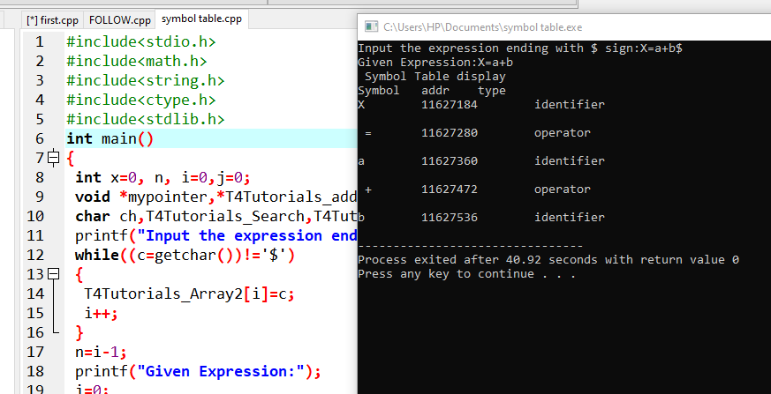

**2Q.SHIFT REDUCE PARSING**

PROGRAM:

#include<stdio.h>

#include<conio.h>

#include<string.h>

int k=0,z=0,i=0,j=0,c=0;

char a[16],ac[20],stk[15],act[10];

void check();

void main()

{

clrscr();

puts("GRAMMAR is E->E+E \n E->E*E \n E->(E) \n E->id");

puts("enter input string ");

gets(a);

c=strlen(a);

strcpy(act,"SHIFT->");

puts("stack \t input \t action");

for(k=0,i=0; j<c; k++,i++,j++)

{

if(a[j]=='i' && a[j+1]=='d')

{

stk[i]=a[j];

stk[i+1]=a[j+1];

stk[i+2]='\0';

a[j]=' ';

a[j+1]=' ';

printf("\n$%s\t%s$\t%sid",stk,a,act);

check();

}

else

{

stk[i]=a[j];

stk[i+1]='\0';

a[j]=' ';

printf("\n$%s\t%s$\t%ssymbols",stk,a,act);

check();

}

}

getch();

}

void check()

{

strcpy(ac,"REDUCE TO E");

for(z=0; z<c; z++)

if(stk[z]=='i' && stk[z+1]=='d')

{

stk[z]='E';

stk[z+1]='\0';

printf("\n$%s\t%s$\t%s",stk,a,ac);

j++;

}

for(z=0; z<c; z++)

if(stk[z]=='E' && stk[z+1]=='+' && stk[z+2]=='E')

{

stk[z]='E';

stk[z+1]='\0';

stk[z+2]='\0';

printf("\n$%s\t%s$\t%s",stk,a,ac);

i=i-2;

}

for(z=0; z<c; z++)

if(stk[z]=='E' && stk[z+1]=='*' && stk[z+2]=='E')

{

stk[z]='E';

stk[z+1]='\0';

stk[z+1]='\0';

printf("\n$%s\t%s$\t%s",stk,a,ac);

i=i-2;

}

for(z=0; z<c; z++)

if(stk[z]=='(' && stk[z+1]=='E' && stk[z+2]==')')

{

stk[z]='E';

stk[z+1]='\0';

stk[z+1]='\0';

printf("\n$%s\t%s$\t%s",stk,a,ac);

i=i-2;

}

OUTPUT:

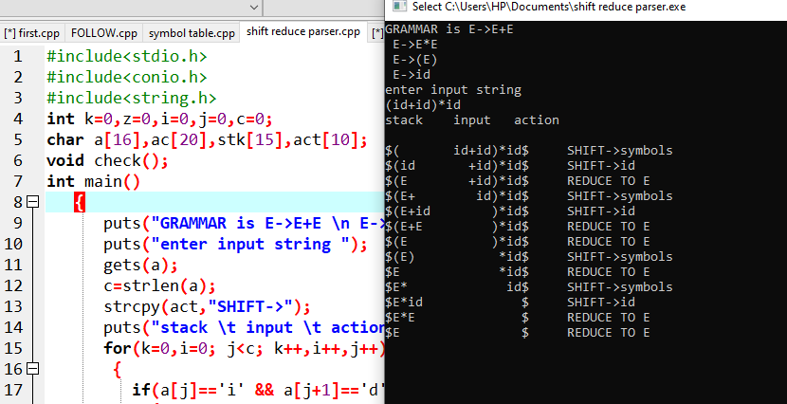

3Q.TOKEN RCOGNITION

PROGRAM:

#include <stdbool.h>

#include <stdio.h>

#include <string.h>

#include <stdlib.h>

bool isDelimiter(char ch)

{

if (ch == ' ' || ch == '+' || ch == '-' || ch == '*' ||

ch == '/' || ch == ',' || ch == ';' || ch == '>' ||

ch == '<' || ch == '=' || ch == '(' || ch == ')' ||

ch == '[' || ch == ']' || ch == '{' || ch == '}')

return (true);

return (false);

}

bool isOperator(char ch)

{

if (ch == '+' || ch == '-' || ch == '*' ||

ch == '/' || ch == '>' || ch == '<' ||

ch == '=')

return (true);

return (false);

}

bool validIdentifier(char* str)

{

if (str[0] == '0' || str[0] == '1' || str[0] == '2' ||

str[0] == '3' || str[0] == '4' || str[0] == '5' ||

str[0] == '6' || str[0] == '7' || str[0] == '8' ||

str[0] == '9' || isDelimiter(str[0]) == true)

return (false);

return (true);

}

bool isKeyword(char* str)

{

if (!strcmp(str, "if") || !strcmp(str, "else") ||

!strcmp(str, "while") || !strcmp(str, "do") ||

!strcmp(str, "break") ||

!strcmp(str, "continue") || !strcmp(str, "int")

|| !strcmp(str, "double") || !strcmp(str, "float")

|| !strcmp(str, "return") || !strcmp(str, "char")

|| !strcmp(str, "case") || !strcmp(str, "char")

|| !strcmp(str, "sizeof") || !strcmp(str, "long")

|| !strcmp(str, "short") || !strcmp(str, "typedef")

|| !strcmp(str, "switch") || !strcmp(str, "unsigned")

|| !strcmp(str, "void") || !strcmp(str, "static")

|| !strcmp(str, "struct") || !strcmp(str, "goto"))

return (true);

return (false);

}

bool isInteger(char* str)

{

int i, len = strlen(str);

if (len == 0)

return (false);

for (i = 0; i < len; i++) {

if (str[i] != '0' && str[i] != '1' && str[i] != '2'

&& str[i] != '3' && str[i] != '4' && str[i] != '5'

&& str[i] != '6' && str[i] != '7' && str[i] != '8'

&& str[i] != '9' || (str[i] == '-' && i > 0))

return (false);

}

return (true);

}

bool isRealNumber(char* str)

{

int i, len = strlen(str);

bool hasDecimal = false;

if (len == 0)

return (false);

for (i = 0; i < len; i++) {

if (str[i] != '0' && str[i] != '1' && str[i] != '2'

&& str[i] != '3' && str[i] != '4' && str[i] != '5'

&& str[i] != '6' && str[i] != '7' && str[i] != '8'

&& str[i] != '9' && str[i] != '.' ||

(str[i] == '-' && i > 0))

return (false);

if (str[i] == '.')

hasDecimal = true;

}

return (hasDecimal);

}

char* subString(char* str, int left, int right)

{

int i;

char* subStr = (char*)malloc(

sizeof(char) * (right - left + 2));

for (i = left; i <= right; i++)

subStr[i - left] = str[i];

subStr[right - left + 1] = '\0';

return (subStr);

}

void parse(char* str)

{

int left = 0, right = 0;

int len = strlen(str);

while (right <= len && left <= right) {

if (isDelimiter(str[right]) == false)

right++;

if (isDelimiter(str[right]) == true && left == right) {

if (isOperator(str[right]) == true)

printf("'%c' IS AN OPERATOR\n", str[right]);

right++;

left = right;

} else if (isDelimiter(str[right]) == true && left != right

|| (right == len && left != right)) {

char* subStr = subString(str, left, right - 1);

if (isKeyword(subStr) == true)

printf("'%s' IS A KEYWORD\n", subStr);

else if (isInteger(subStr) == true)

printf("'%s' IS AN INTEGER\n", subStr);

else if (isRealNumber(subStr) == true)

printf("'%s' IS A REAL NUMBER\n", subStr);

else if (validIdentifier(subStr) == true

&& isDelimiter(str[right - 1]) == false)

printf("'%s' IS A VALID IDENTIFIER\n", subStr);

else if (validIdentifier(subStr) == false

&& isDelimiter(str[right - 1]) == false)

printf("'%s' IS NOT A VALID IDENTIFIER\n", subStr);

left = right;

}

}

return;

}

int main()

{

char str[100] = "int a = b + 1c; ";

parse(str);

return (0);

}

OUTPUT:

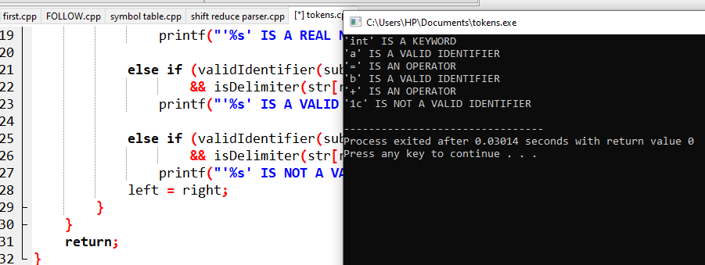

4Q.OPERATOR PRECEDENCE

PROGRAM:

#include <stdio.h>

int main()

{

int a,b;

double output;

printf("Please enter any 2 numbers \n");

scanf("%d\n\t%d",&a,&b);

output=(a-b)*(a+b*a)+a/b;

printf("output of %d and %d is = %lf ",a, b,output);

return 0;

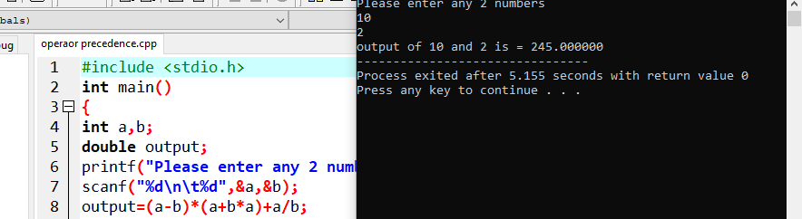

**LEX PROGRAMS:**

**1Q.CONSTANT**

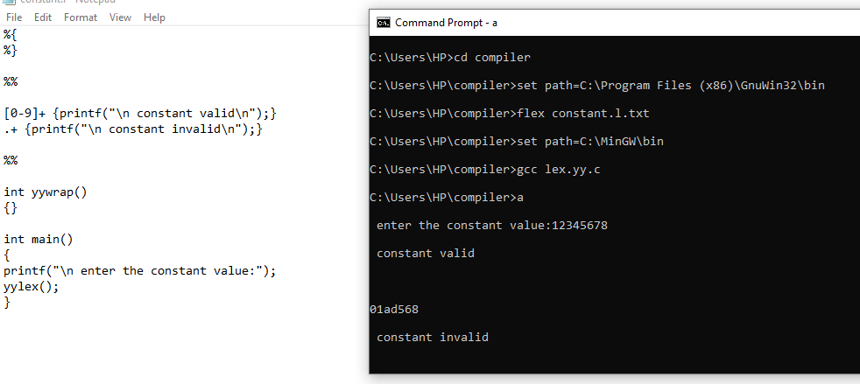

**2Q.CAPITAL**

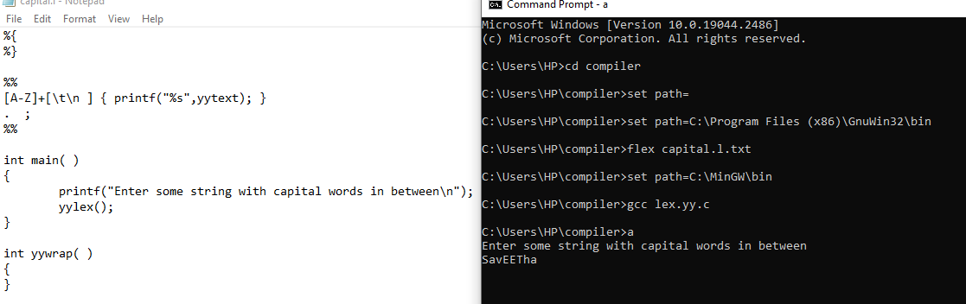

**3Q.HTML**

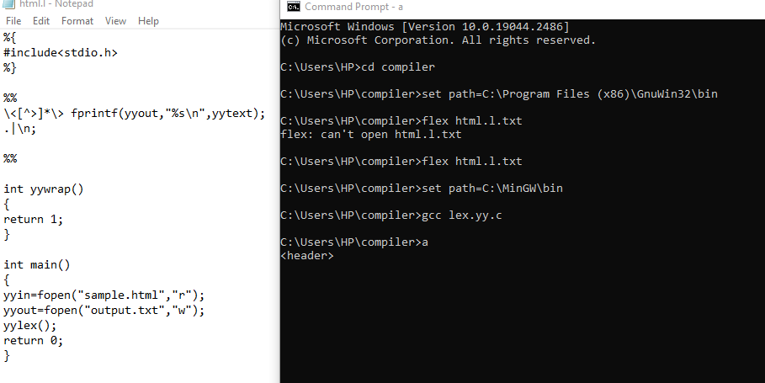

**4Q.MACRO AND HEADER**

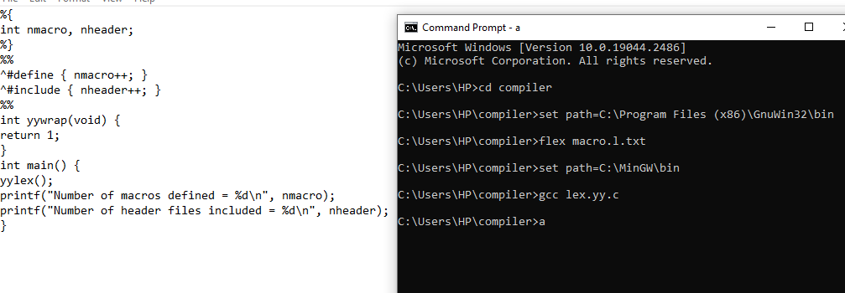

**5Q.ADD LINE**